1. **Write a Python program to convert kilometers to miles?**

**ans:** 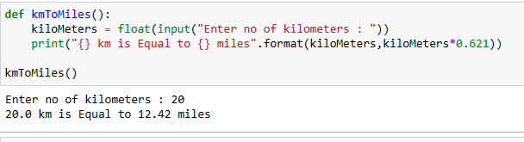

1. **Write a Python program to convert Celsius to Fahrenheit?**

**Ans:**

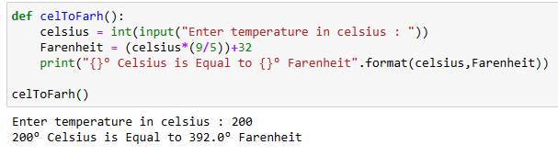

1. **Write a Python program to display calendar?**

**Ans:** 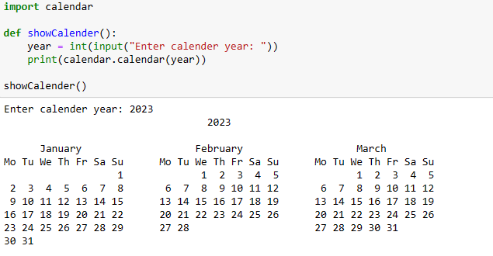

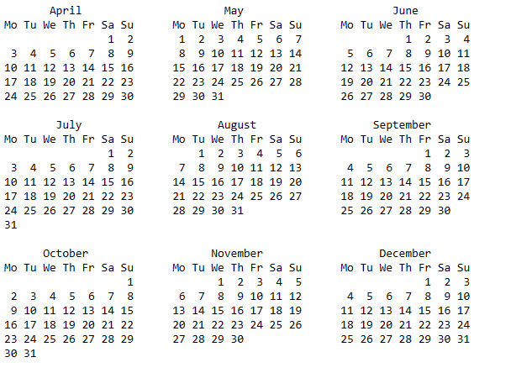

1. **Write a Python program to solve quadratic equation?**

**ans:**

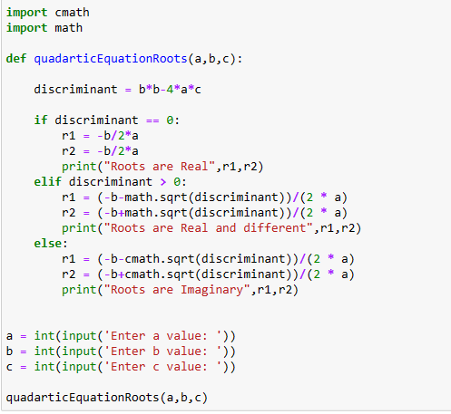

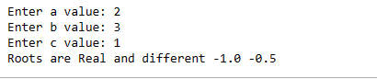

1. **Write a Python program to swap two variables without temp variable?**

**Ans:** 